MEASURING THE USER EXPERIENCE

Overview
This report is based on a fictitious online study comparing two online banking websites: Bank of America and Wells Fargo.

Overall Task Success
A CHI-square test was run on all overall task success. The conclusion of the test was that it was statistically very sure (CHI-square=0.01) that BOA online banking website (89.63% vs 81.47%) users are more able to accomplish tasks than Wells Fargo online banking website users. For all task success tests, the actual results and the expected results were put through the CHITEST.

Individual Task Success
A CHI-square test was run on individual task. Half of the tests we weren’t statistically sure of. Task 1 = 0.71 Chi-square. Task 2 = 0.45 Chi-square. Task 3 = 0.28 Chi-square. Task 6 = 0.78 Chi-square. Task 7 = 0.30 Chi-square. This is because these tasks mean results are not significantly different.

However, Task 4, 5, 8, 9, and 10 all came back at or below 0.05 CHI-square. What the equation was able to conclude is that this confirms the idea that BOA website users are more able to accomplish their tasks than Wells Fargo online banking website users.

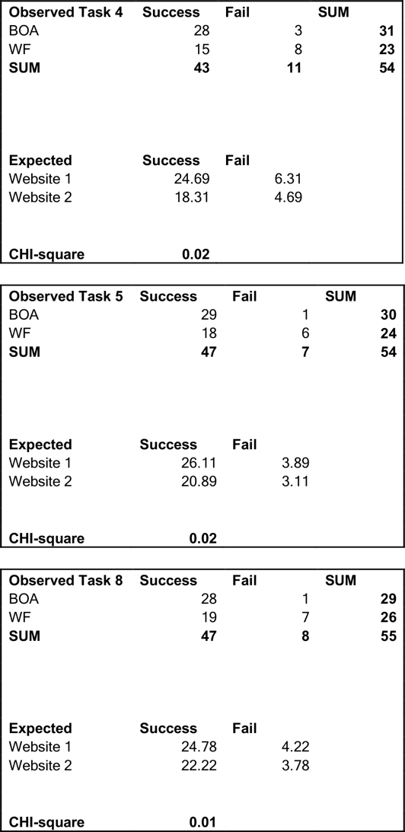
Individual Tasks Statistically Proven with CHI-square Tables

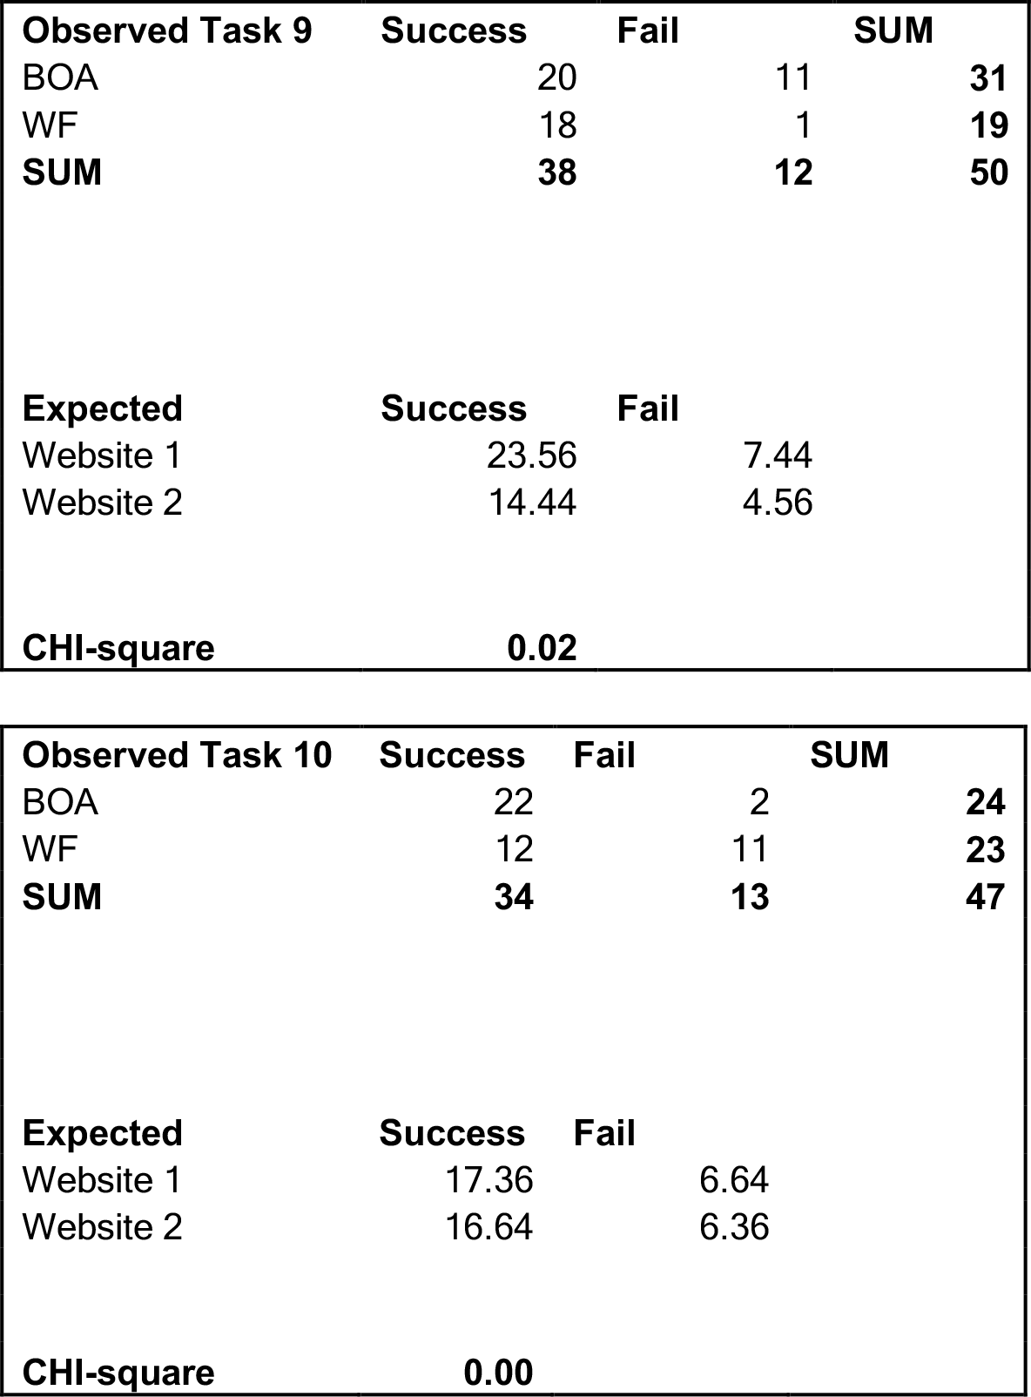

Overall Task Success CHI-Square

Observed | Success | Fail | SUM
BOA | 242 | 28 | 270
WF | 189 | 43 | 232
SUM | 431 | 71 | 502
Expected | Success | Fail
Website 1 | 231.81 | 38.19
Website 2 | 199.19 | 32.81
CHI-square | 0.01

Overall Task Success Chart

Task Time Analysis Overall
Task Time overall was the next to be analyzed. The result overall of the equations were shown to NOT be statistically very sure (p-value=0.18) that BOA website users are faster at task then WF users. The results could be random. This is because many of the results are too close to each other. When individual tasks are measured, the results show that there are some that have means that are significantly different, but not many. It suggests that BOA task time may be faster than WF, however, we can’t say for certain. It is overall so close that it may be random.

Individual Task Time Measure
Individual Task Times were the next to be measured. Six of the task times were too close to each other be declared statistically significant. Task 1 = 0.35 p-value, Task 2 = 0.48 p-value, Task 4 = 0.12 p-value, Task 5 = 0.36 p-value, Task 6 = 0.30 p-value, and Task 7 = 0.42 p-value.

The individual tasks with statistical certainty were Task 3, Task 8, Task 9, and Task 10.

All p-values were generated when a t-test was run on individual tasks times array from Bank of America and individual task times from Wells Fargo. The equation also used a two tail two sample.

T-Test Task 1 |  |  |  |  | T-Test Task 2 |  | T-Test Task 3
p-value |  |  |  | 0.35 | p-value | 0.48 | p-value | 0.02
T-Test Task 4 |  |  |  |  | T-Test Task 5 |  | T-Test Task 6
p-value |  |  | 0.12 |  | p-value | 0.36 | p-value | 0.30
T-Test Task 7 |  |  |  |  | T-Test Task 8 |  | T-Test Task 9
p-value |  | 0.42 |  |  | p-value | 0.00 | p-value | 0.00
T-Test Task 10

p-value |  | 0.00

Task Ease Analysis Overall
Task Ease overall was the next to be analyzed. The result of the equations were overall shown to be statistically very sure (p-value= 0.01) that BOA online banking tasks were easier then WF users. This is because enough of the tasks had significantly different outcomes from one another in ease.

Individual Task Ease Analysis
As for individual task ease, Task 1, Task 2, Task 5, Task 6, Task 7 were all too close to call and could be random. Task 3, Task 4, Task 8, Task 9, and Task 10 were significantly different to be declared most likely reliable.

All p-values were generated when a t-test was run on individual tasks ease array from Bank of America and individual task ease array from Wells Fargo. The equation also used a two tail two sample.

T-Test Task 1 |  | T-Test Task 2 |  | T-Test Task 3
p-value | 0.19 | p-value | 0.29 | p-value | 0.03
T-Test Task 4 |  | T-Test Task 5 |  | T-Test Task 6
p-value | 0.00 | p-value | 0.26 | p-value | 0.32
T-Test Task 7 |  | T-Test Task 8 |  | T-Test Task 9
p-value | 0.33 | p-value | 0.07 | p-value | 0.00
T-Test Task 10

p-value | 0.00

Overall Ease and Visual Appeal
Next to be tested was whether there was a correlation between overall ease and visual appeal. Overall, the reports seem to have enough data for there to be an accurate report from both Bank of America and Wells Fargo. From this, the report can deduce that both banks have a slight relationship correlation between overall ease and visual appeal. Wells Fargo appears to have a better result here. This is interesting because in two of the three previous tests, Task Success and Task Ease, Bank of America seems to have better results.

BFA Correlation
r | 0.32364512
n | 45
t | 2.24300478
p | 0.03
WF Correlation
r | 0.34900227
n | 39
t | 2.26533814
p | 0.03

SUS Score Analysis
For the SUS Score, a Frequency Distribution equation was run. This showed that Bank of America (mean = 62.4) came in slightly ahead of Wells Fargo (mean 58.7) by a very narrow margin.

BOA
Frequency Distribution: |  |  |  | Percentiles:
40 | <=40 | 6 |  | 10th | 35.0
50 | 41-50 | 1 |  | 25th | 52.5
60 | 51-60 | 13 |  | 50th | 62.5
70 | 61-70 | 8 |  | 75th | 75.0
80 | 71-80 | 8 |  | 90th | 84.5
90 | 81-90 | 7 |  | Mean | 62.4
100 | 91-100 | 0
 |  |  |  | Count: | 43
WF
Frequency Distribution: |  |  |  | Percentiles:
40 | <=40 | 8 |  | 10th | 29.0
50 | 41-50 | 5 |  | 25th | 50.0
60 | 51-60 | 6 |  | 50th | 62.5
70 | 61-70 | 5 |  | 75th | 75.0
80 | 71-80 | 11 |  | 90th | 81.0
90 | 81-90 | 4 |  | Mean | 58.7
100 | 91-100 | 0
 |  |  |  | Count: | 39

Final Summary
It appears that Bank of America has an overall better online banking website, based on these tests. The one that statistically isn’t assured is the Task Time analysis, because the overall P Value was too high.

One of the interesting issues is Task 9 and 10. Those two individual tasks appear to have the greatest differences in all the tests. Both banks should look at exactly what is going on with those tasks and make user experience adjustments accordingly.

Wells Fargo does have an advantage when it comes to Overall Ease of Use and Visual Appeal. However, it appears that they will have a more overall adjustments to make when it comes to addressing their other issues when compared to Bank of America.

